A.V.KAVERI,
(192512188).
Experiment No: 10
Title: IoT-Based Smart Agriculture and Automated Irrigation using Python (Google Colab)

Aim
To design and simulate an IoT-based Smart Agriculture and Automated Irrigation system using Python in Google Colab that monitors soil moisture, temperature, and humidity, automatically controls irrigation based on thresholds, and visualizes agricultural parameters through real-time graphs and reports.

Objective
The objective of this experiment is to demonstrate how IoT sensors can be simulated to monitor soil and environmental conditions. The system evaluates sensor data against predefined thresholds, decides whether irrigation is required, and visualizes the results. This experiment shows how smart farming can be implemented using IoT and AI concepts without physical sensors.

Software Requirements
- Google Colab
- Python 3.x
- Libraries:
  - random → simulate sensor values
  - time → simulate delays
  - pandas → tabular report generation
  - matplotlib → graphical visualization
  - IPython.display → clear and update live output

Theory
Smart agriculture integrates IoT sensors to monitor soil moisture, temperature, and humidity. Automated irrigation systems use these sensor readings to decide when to water crops, ensuring efficient water usage and improved yield. In this simulation, sensor values are generated randomly, compared against thresholds, and irrigation status is determined. Graphs and reports provide a clear visualization of the system’s performance.

Algorithm
- Start the program.
- Import required Python libraries.
- Create a list of farm plots.
- For each plot:
  - Generate random values for soil moisture, temperature, and humidity.
  - Compare values with thresholds.
  - Decide irrigation status (ON/OFF).
  - Display plot details and graphs.
  - Pause simulation for 2 seconds.
- Store sensor data in a DataFrame.
- Display final report table.
- Save report as CSV file.
- Stop the program.

Flowchart
Code
START
|
Import Libraries
|
Generate Sensor Data
|
Check Thresholds
|
┌─────────────┴─────────────┐
| |
Irrigation ON Irrigation OFF
| |
└─────────────┬─────────────┘
|
Display Graphs & Status
|
Store Sensor Data
|
Generate Final Report
|
END

Program (Python – Google Colab)
python
# ============================================
# Case Study : Smart Agriculture & Irrigation
# Google Colab Simulation
# ============================================
import random
import time
import pandas as pd
import matplotlib.pyplot as plt
from IPython.display import clear_output
# -------------------------
# Farm Plots
# -------------------------
plots = ["Plot 1","Plot 2","Plot 3","Plot 4","Plot 5"]
moisture_data = []
temperature_data = []
humidity_data = []
irrigation_status = []
# -------------------------
# Simulation
# -------------------------
for plot in plots:
moisture = random.randint(20, 80) # Soil moisture %
temp = round(random.uniform(20, 40),1) # Temperature °C
humidity = random.randint(40, 90) # Humidity %
moisture_data.append(moisture)
temperature_data.append(temp)
humidity_data.append(humidity)
if moisture < 40 or temp > 35:
status = "IRRIGATION ON"
color = "red"
else:
status = "IRRIGATION OFF"
color = "green"
irrigation_status.append(status)
clear_output(wait=True)
print("="*60)
print("SMART AGRICULTURE & IRRIGATION SYSTEM")
print("="*60)
print("Plot :", plot)
print("Soil Moisture :", moisture,"%")
print("Temperature :", temp,"°C")
print("Humidity :", humidity,"%")
print("Irrigation Status :", status)
plt.figure(figsize=(12,4))
# Soil Moisture
plt.subplot(1,3,1)
plt.bar(["Moisture"],[moisture],color="blue")
plt.ylim(0,100)
plt.title("Soil Moisture")
# Temperature
plt.subplot(1,3,2)
plt.bar(["Temp"],[temp],color="orange")
plt.ylim(0,50)
plt.title("Temperature")
# Humidity
plt.subplot(1,3,3)
plt.bar(["Humidity"],[humidity],color=color)
plt.ylim(0,100)
plt.title("Humidity")
plt.tight_layout()
plt.show()
time.sleep(2)
# -------------------------
# Final Report
# -------------------------
report = pd.DataFrame({
"Plot": plots,
"Soil Moisture": moisture_data,
"Temperature": temperature_data,
"Humidity": humidity_data,
"Irrigation Status": irrigation_status
})
print("\nFINAL REPORT\n")
print(report)
report.to_csv("Smart_Agriculture_Report.csv",index=False)
print("\nCSV File Saved Successfully")

Input
- Soil Moisture Values
- Temperature Values
- Humidity Values

Output
- Real-time graphs for soil moisture, temperature, and humidity.
- Irrigation status (ON/OFF) for each plot.
- Final CSV report of all plots.

Observations
- Plots with low soil moisture or high temperature trigger irrigation.
- Normal plots keep irrigation OFF.
- Graphs clearly visualize agricultural parameters.

Applications
- Smart farming and crop management
- IoT-based irrigation systems
- Water conservation in agriculture
- Remote farm monitoring

Advantages
- Efficient water usage
- Real-time monitoring of soil and environment
- Automated irrigation decisions
- Easy to simulate and implement

Limitations
- Uses simulated sensor data
- No real IoT devices involved
- Suitable only for academic demonstration

Result
The IoT-based Smart Agriculture and Automated Irrigation system was successfully simulated using Python in Google Colab. The system generated soil and environmental parameters, detected irrigation needs, controlled irrigation status, and displayed results through graphs and a final CSV report. Thus, the experiment demonstrated effective smart farming simulation in an academic environment.

Output
============================================================
SMART AGRICULTURE & IRRIGATION SYSTEM
============================================================
Plot : Plot 5
Soil Moisture : 49 %
Temperature : 21.7 °C
Humidity : 68 %
Irrigation Status : IRRIGATION OFF
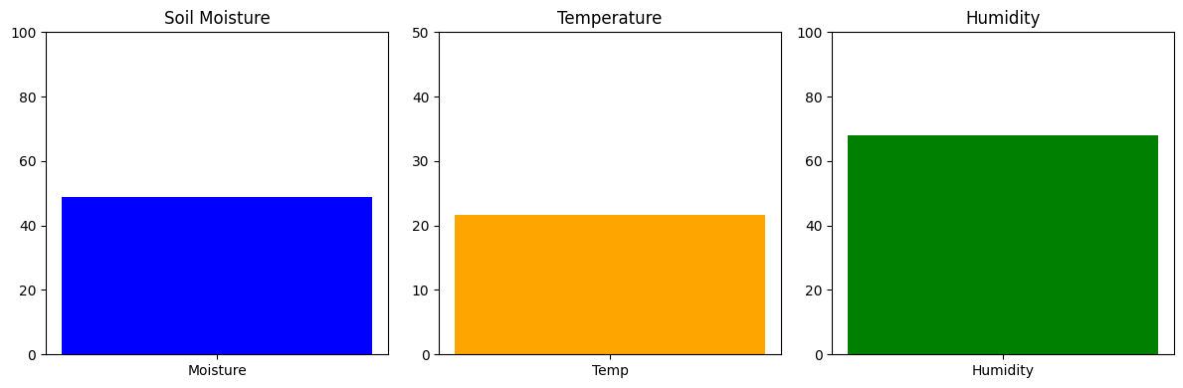
FINAL REPORT

Plot Soil Moisture Temperature Humidity Irrigation Status
0 Plot 1 20 27.1 78 IRRIGATION ON
1 Plot 2 56 21.0 64 IRRIGATION OFF
2 Plot 3 36 21.3 64 IRRIGATION ON
3 Plot 4 69 39.7 45 IRRIGATION ON
4 Plot 5 49 21.7 68 IRRIGATION OFF

CSV File Saved Successfully

